1.Given an array A of size N where the array elements contain values from 1 to N with duplicates, the task is to find total number of subarrays which start and end with the same element.

#include <bits/stdc++.h>

using namespace std;

void cntArray(int A[], int N)

{

int result = 0;

for (int i = 0; i < N; i++) {

result++;

int current_value = A[i];

for (int j = i + 1; j < N; j++) {

if (A[j] == current_value) {

result++;

}

}

}

cout << result << endl;

}

int main()

{

int A[100],N;

cin>>N;

for(int i=0;i<N; i++)

cin>>A[i];

cntArray(A, N);

return 0;

}

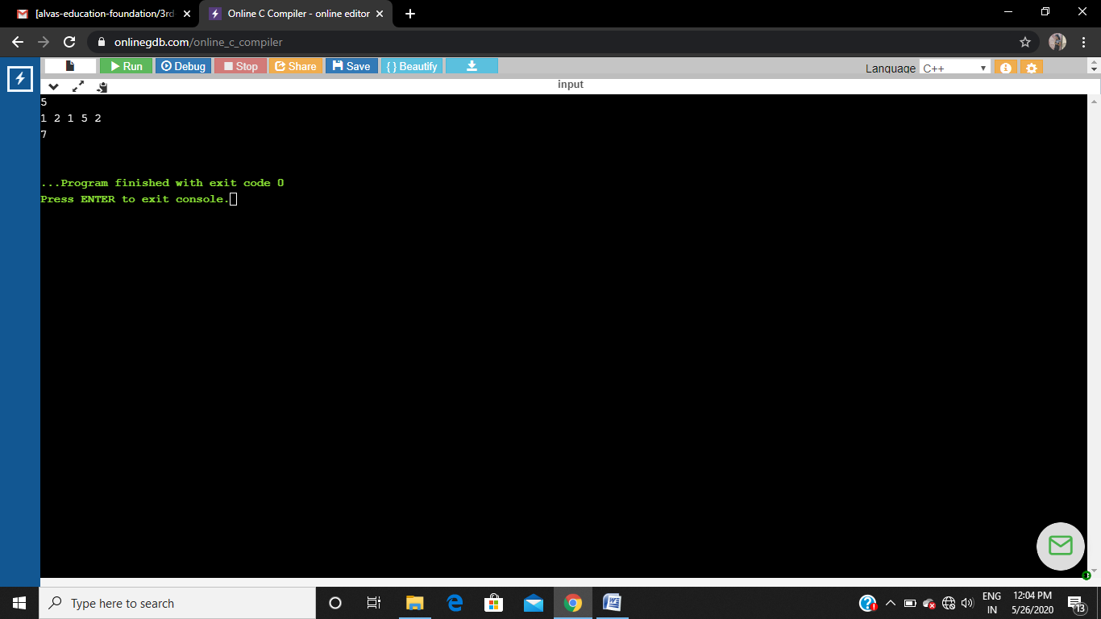

2.Write a program in C to print all permutations of a given string

#include <stdio.h>

#include <string.h>

void swap (char *x, char *y)

{

char temp;

temp = *x;

*x = *y;

*y = temp;

}

void permute(char *a, int i, int n)

{

int j;

if (i == n)

printf("%s\n", a);

else {

for (j = i; j <= n; j++)

{

swap((a + i), (a + j));

permute(a, i + 1, n);

swap((a + i), (a + j));

}

}

}

int main()

{

char a[20];

int n;

printf("Enter a string: ");

scanf("%s", a);

n = strlen(a);

printf("Permutaions:\n");

permute(a, 0, n - 1);

getchar();

return 0;

}

